Vectors Review

1/ A kayaker can travel in flatwater with a speed of 6kmh-1 . She aims directly towards an island that is 20 km away and starts paddling. A tidal current is flowing at 2 kmh-1 in a direction of 00 .

00

20 km

Kayaker

450

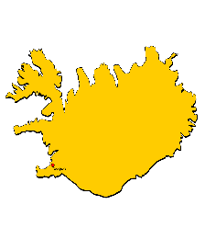

[This Photo](http://www.landkartenindex.de/kostenlos/?cat=126) by Unknown Author is licensed under [CC BY](https://creativecommons.org/licenses/by/3.0/)

( a) How far is the kayaker away from the island after 3 hours of paddling?

(b) Her friend is able to paddle with the same flat water speed but choses to compensate for the current by offsetting his direction. How long does it take his friend to reach the island?

2. An object has 3 forces acting on it as shown below

8N

5N

10N

300

(a ) Find the sum of all three vectors, include both size and direction

(c ) If a 4th force was added so that it was to stop the mass from accelerating what would be it size and direction?

3. An object changes its motion from V1 to V2 as shown below

V2 = 10 ms-1

V1 = 20 ms-1

300

1. Determine the direction of the average acceleration based on the change in motion

4. A cyclist is traveling at 10 ms-1 in the horizontal directionand rain drops fall vertically at 5 ms-1 . What is the velocity of the rain relative to the cyclist?

5. A swimmer can swim with a maximum flatwater speed of 3ms-1 . He is attempting to cross a river as shown below.

Width of River = 90 m

Swimmer 3 ms-1 (flatwater)

River Velocity = 5 ms-1

1. Assume the swimmer wants to reach a point directly opposite. How long will it take?
2. Suppose the swimmer wants to take the shortest amount of time to cross the river. How long will it take?